

**King AbdulAziz University**

**MIS Department**

**Faculty of Economics and Administration**

**Human Computer Interaction - MIS 373,**

**Term 2, 2023**

### [Mobily E-shop](https://shop.mobily.com.sa/?lang=en)

[](https://shop.mobily.com.sa/?lang=en)

<https://imalzahrani.wixsite.com/mobily-shop>

Fadi Hussien Allabban 2040615

Ibrahim Abdulrhaman Alzahrani 2035287

Mohammed Saqer Alzaharni 1935819

Instructor: Dr. Mohammed Al Sarhan

**1. - Understanding the Problem**

We have identified the potential users of the system whom are the buyers, new Mobily customers and existing customers looking for services. Then, we have analysed the main activates the users are doing which are buying phones, subscribe in internet services, purchasing prepaid and postpaid SIMs.

After that, we have studied the main functions that the users need, nd they were Providing easy access to the information and website services that the customer need. Later, we have applied the POUR 4 principles on our design to locate the constraints which are:

* **Perceivable** in which users are capable to understand the displayed information such as that the website menu is clearly shown.
* **Operable** for users in order to ease their Navigation like providing vertical scroll bar.
* **Understandable** so that the Information must be easy to grasp thus we have defined the labels clearly.
* **Robust** which means Content needs to be reliable enough to be understood by numerous user devices, and we have taken into consideration the different devices systems compatibility to the website.

**Mobily website Problems**

The menus are not appearing clearly because there is no background which helps the user to select the service. Also, there is no sign in or sign-up button to save the users information. Furthermore, the back to home page button doesn't exist.

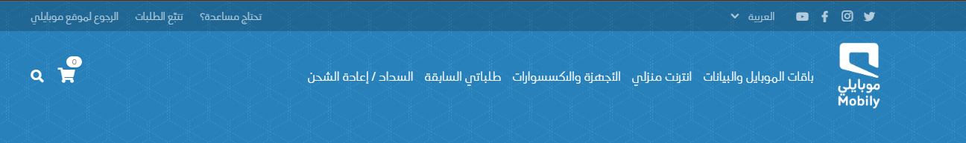

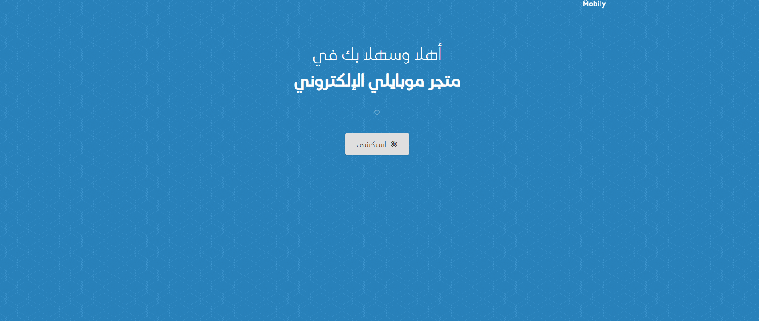

The search procedure in the website lacks many features such as search box and search help

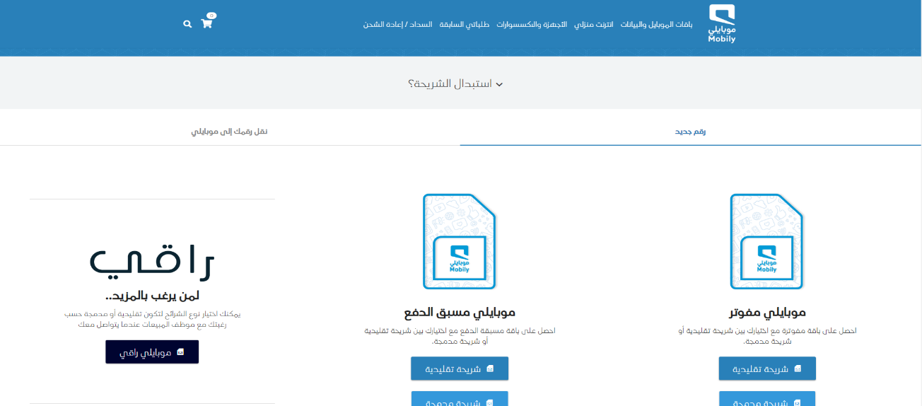The main page of the website provides the users with unnecessary information, and it doesn't contain any ads which cause to have a lot of unused spaces.

**Criteria used to judge if our design is a success or not****:**

1. **Does the design fulfill its purpose?** It must display all necessary information in order to transmit the message or compel the user to take action.
2. **Is the message easy to understand?** A strong design will guide the audience's eyes through the information, ensuring that the message is instantly understandable.
3. **Functionality** is defined as anything that supports the user in achieving their goal more quickly and easily, such as website options and tools.

**2. Design alternatives**

**Project Description:**

The proposal specifies the site in such a way that it is effective for all types of users, whether they are Mobily clients or external consumers, that the shop includes all products in an organized and clear manner for the user, and that the site has a high percentage of users.‏‏

**Design Summary:**

**Which tasks will be easiest to support? Which are hardest?**

It is simple to create a new interface that successfully serves the user and to improve the lists and advertisement pages, but it is difficult to connect the user's wishes and search history with the materials shown to him.

**What are some trade-offs?**

The homepage of the website has been changed to incorporate a user login box in the top bar, allowing users to check account details, save products to favourites for quicker access, and even add a welcome message.

Unlike the original site, where the user is brought to a page for SIMs and ESIMs directly, where it is possible that the user may not need it, an advertisement page was developed in the main interface to take the user to various products and offers.

**Design Space:**

In order to boost user confidence in the website and make the request process secure and quick, the website features page has been added to the main page. In order to attract visitors and encourage them to utilize the site for their intended purpose, an optional newsletter has also been created, where users can enter their email to receive updates on site additions, changes, and news.

A basic assistance center page has also been placed at the bottom of each page. It consists of three boxes: one for user service and communication, one for the site's terms and conditions and payment options, and one for the site's social media networks.

**A brief overview of the design:**

we have sketched a storyboard of the website functions that contains sequence of the initial phases of the design.

**Storyboard:**

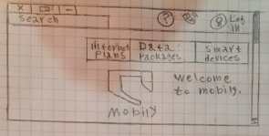

2

1

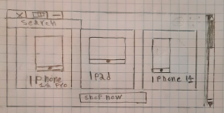

The user enters to the main page, and choose a service.

The user selects the type of the product he wants to purchase.

3

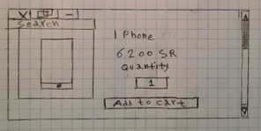

4

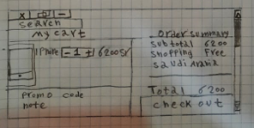

The price and quantity and other informations about the product appear.

The order summary page appear and user proceed to payment page.

**Advantages of the design:**

The design's benefits can be summed up in fewer steps taken by the user to access the desired service, in making the buttons more obvious to the user and utilizing more descriptive labels, and in assisting the user to avoid issues to the greatest extent possible.

**Disadvantages of the design:**

Because it takes a lot of design and software resources and tools to update the site's developments and inform users of them via the newsletter service, the site may have drawbacks.

**express gathered feedback:**

Giving some family members and friends the experience of the new and previous site, it became clear that the steps to reach the desired product or lists became less in the current design, so the time was calculated for the process of purchasing a product as shown in the previously mentioned storyboard.

In this part we have drawn a diagram which explain the steps that the users will see when they visit the website as following:

3- The price and quantity appear

1- User enter to the main page

4- Order summary appear

2- Choose the service

Purchasing a product from Mobily store

**3- Prototype**

****In this part, we have used Wix.com to design our website. Below are screenshots of the pages in the website.

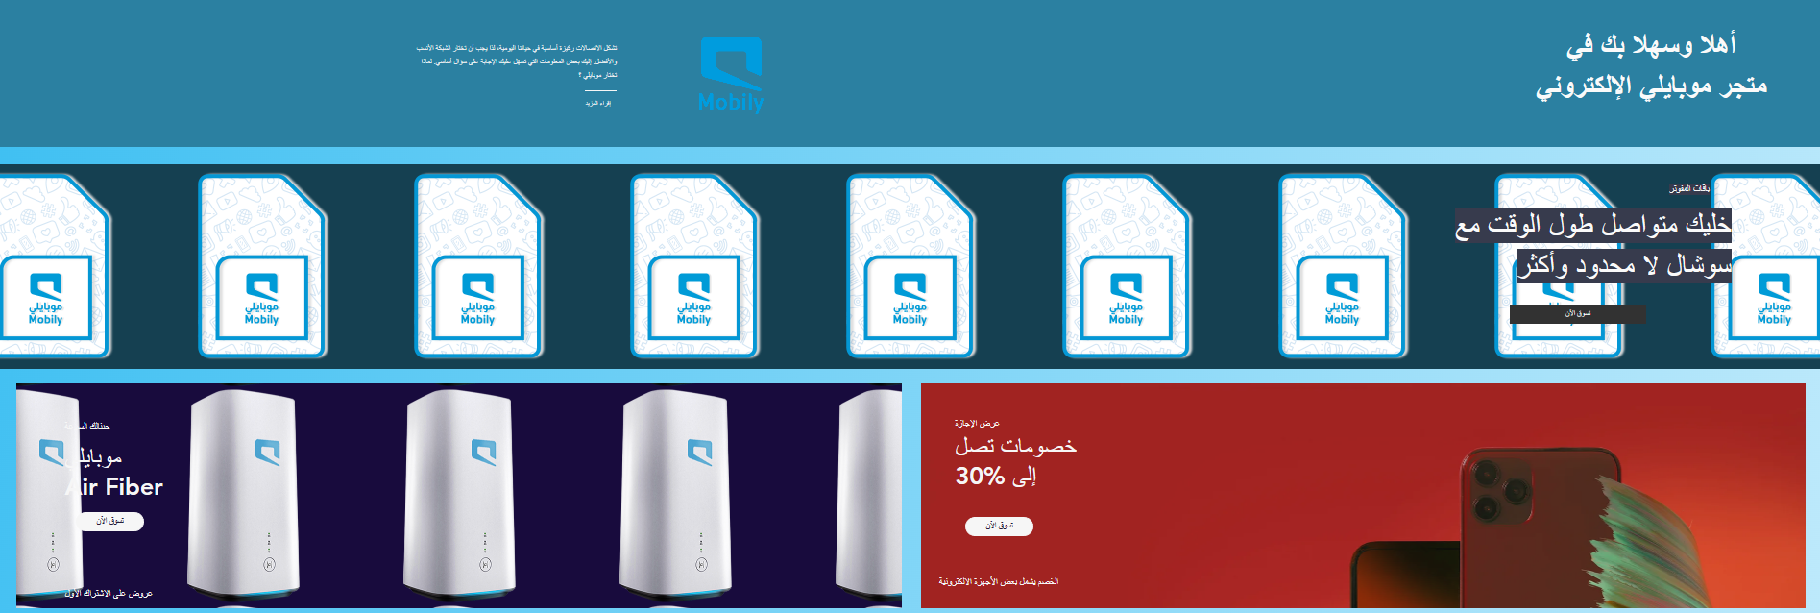

The main page is the first page that face the customers, and it contains the 3 categories which are smart devices, data and internet packages. When the users click on any of them it will directly transfer them to the selection page.

To ensure that the users can read it fast and simply, the material must be clear, with well-executed design concepts and font.

The selection page contains the devices that the customer can choose from, and brief information about the device. When the customer clicks on any device it will transfer them to the salary and quantity page.

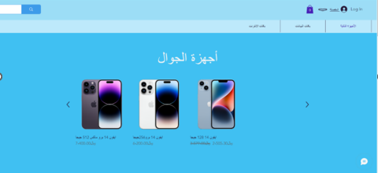

Quantity and Price page includes a fill-in textbox where the users enter the quantity of the device they want, and then press Add to Cart button so that the website automatically calculate the price.

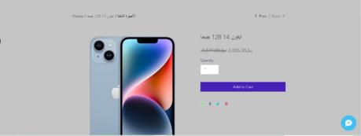

The order summary page eventually appears for the customers to revise the order details, and confirm the order by clicking on checkout button.

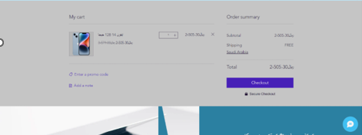

**The website link:** <https://imalzahrani.wixsite.com/mobily-shop/cart-page?appSectionParams=%7B%22origin%22%3A%22cart-popup%22%7D>

1. **Evaluation:**

Because the site was not entirely committed to the requirements of the sites in the Kingdom of Saudi Arabia, it must be fully adhered to, such as ease of access and sufficient clarity of information, to assist development and Vision 2030.

In terms of the questions, we wanted to know if we had achieved the necessary consistency on the site as well as the usability of the user. Our survey included research into the user interface and presentation technique, such as button size, typeface, site aesthetics, and overall consumer experience.

The Mobily website was not awful, but it needed certain modifications, as indicated in the principal guideline for Kingdom of Saudi Arabia websites, therefore some of them were adjusted to be supportive and affiliated in our design.

**What aspects of your design "worked" and what failed to meet our specifications?**

Some features of the program were outstanding and kept up with the user, seeking his comfort and benefit from the site more, such as the help center page, which is located at the bottom of each page it effectively serves the user. Also, the newsletter is considered as one of the best concept designs, since it aims to attract the user to the site, based on a clear objective that he noticed from an advertisement offered to him through the newsletter.

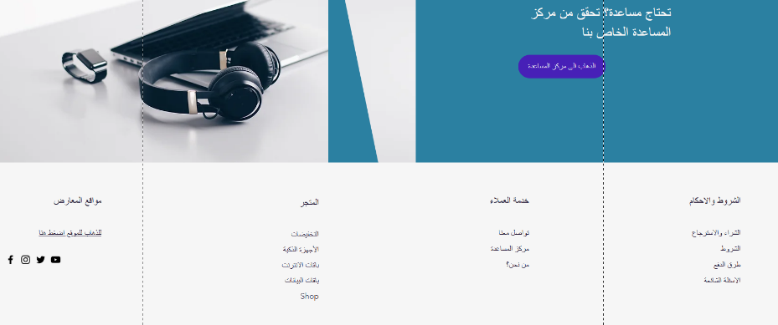

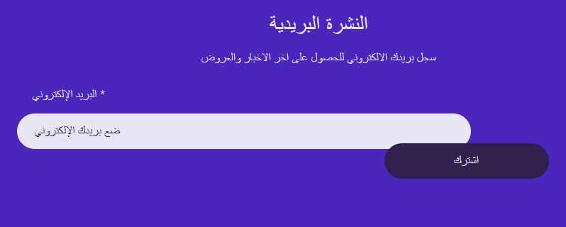

**What if we had more time to work on the design?**

If we had more time on the design the site will be effective with client wishes and search records so that they are connected with and linked to the products that display to the user when checking in with his personal account, increasing the site's profit.